Moms, do you walk in fear, anger
or perfection when you parent?
2 Corinthians says, “We walk by faith, not by sight.”
Learn how to walk in faith, peace & grace…together!
SPEAKERS: [FirstName LastName], and
Video Sessions featuring Camille Cates,
(author of “First Love: Embracing a Love that Lasts”)
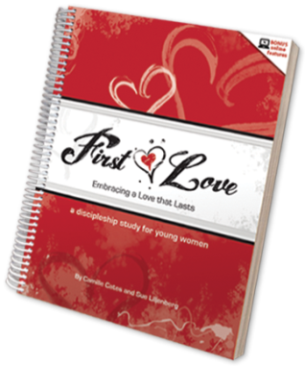

COST: [$Cost / FREE]
WHERE: [LocationName]
[LocationAddress]
WHEN: [WeekDay], [Date]
[Start – EndTime]
Please register by [RegisterByDate]
To learn more & register visit:
[PhysicalLocation ex: “church kiosk”]
[WebsiteUrl / FacebookUrl]
[EmailAddress / Phone Contact]

